Types of Memory in Java

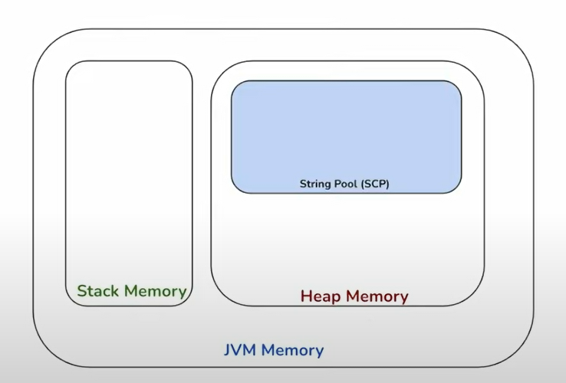

Classes and Objects

A class in Java is a set of objects which shares common characteristics/ behaviour and common properties/attributes.

For example, Student is a class while a particular student named Ravi is an object.

**Inheritance**

**Single Inheritance**

public class A

{

public void display()

{

System.out.println(“I am a method from Class A”);

}

}

class B extends A

{

public void print()

{

System.out.println(“I am a method from Class B”);

}

public static void main(String[] args)

{

B objB=new B();

objB.display();

objB.print();

}

}

–

**Multi-level Inheritance**

class Electronics

{

public Electronics()

{

print “Electronics”;

}

public void deviceType(“Class Electronics”);

{

print “Device Type: Electronics”;

}

}

class Grinder extends Electronics

{

public Grinder()

{

print “Class Grinder”;

}

public void category()

{

print “Category: Grinder”;

}

}

class WetGrinder extends Grinder

{

public WetGrinder()

{

print “Class WetGrinder”;

}

public void grinding_tech()

{

print “Grinding Technology: WetGrinder”;

}

}

public class MultilevelInheritanceExample

{

public static void main(String[] args)

{

WetGrinder wt=new WetGrinder();

wt.deviceType();

wt.category();

wt.grinding_tech();

}

}

—

**Hierarchical Inheritance in Java**

public class ClassH1

{

public void dispH1()

{

System.out.println(“display method of classH1”);

}

}

public class ClassH2 extends ClassH1

{

public void dispH2()

{

System.out.println(“display method of classH2”);

}

}

public class ClassH3 extends ClassH1

{

public void dispH3()

{

“Display method of ClassH3”

}

}

public class ClassH4 extends ClassH1

{

public void dispH4()

{

“Display method of ClassH4”

}

}

public class HierarchicalInheritanceTest

{

public static void main(String args[])

{

ClassH2 h2=new ClassH2();

h2.dispH2();

h2.dispH1();

ClassH3 h3=new ClassH3();

h3.dispH3();

h3.dispH1();

ClassH4 h4=new ClassH4();

h4.dispH4();

h4.dispH1();

}

}

Output:

Display method of ClassH2

Display method of ClassH1

Display method of ClassH3

Display method of ClassH1

Display method of ClassH4

Display method of ClassH1

**Model View Controller**